**REAL-TIME RIVER WATER QUALITY MONITORING AND CONTROL SYSTEM**

**NALAIYA THIRAN PROJECT**

A PROJECT REPORT

*Submitted by*

KALAIVANAN M 190701044

JAYALAKSHMAN S 190701042

JEEVA K 190701303

KABILESHWAR 190701304

**BACHELOR OF ENGINEERING**

**IN**

**ELECTRONICS AND COMMUNICATION ENGINEERING**

**SRI VENKATESWARA COLLEGE OF ENGINEERING**

**(An Autonomous Institution, Affiliated to Anna University, Chennai)**

**CHENNAI– 600 025**

November 2022

**BONAFIDECERTIFICATE**

Certified that this project report titled “**Real-Time River Water Quality Monitoring and Control System by NALAIYA THIRAN PROJECT BASED LEARNING Program*”***, is the bonafide work of **KALAIVANAN M (190701044), JAYALAKSHMAN S (190701042), JEEVA K (190701303), KABILESHWAR S(190701304)** who carried out the work under faculty mentor and industry mentor supervision, for the partial fulfilment of the requirements for the award of the degree of **BACHELOR OF ENGINEERING IN ELECTRONICS AND COMMUNICATION .**

Certified further that to the best of my knowledge and belief, the work reported here in does not form part of any other thesis or dissertation on the basis of which a degree or an award was conferred on an earlier occasion

**ABSTRACT**

Current water quality monitoring system is a manual system with a monotonous process and is very time-consuming. This paper proposes a sensor-based water quality monitoring system. The system consists of several sensors which is used to measure physical and chemical parameters of the water. The main components of Wireless Sensor Network (WSN) include a microcontroller for processing the system, communication system for inter and intra node communication and several sensors. Real-time data access can be done by using remote monitoring and Internet of Things (IoT) technology.

Now a day’s Internet of things (IoT) is an innovative technological phenomenon. It is shaping today’s world and is used in different fields for collecting, monitoring and analysis of data from remote locations. IoT integrated network if everywhere starting from smart cities, smart power grids, and smart supply chain to smart wearable. Though IoT is still under applied in the field of environment it has huge potential. It can be applied to detect forest fire and early earthquake, reduce air population, monitor snow level, prevent landslide, and avalanche etc. Moreover, it can be implemented in the field of water quality monitoring and controlling system. Water quality monitoring has gained more interest among researchers in this twenty-first century. Numerous works are either done or ongoing in this topic focusing on various aspects of it. The key theme of all the projects was to develop an efficient, cost-effective, real-time water quality monitoring system which will integrate wireless sensor network and internet of things. In this research, we monitor the physical and chemical parameters of water bodies inside Chittagong city by using an IoT based sensor network.

**TABLE OF CONTENTS**

|  |  |  |
| --- | --- | --- |
| **CHAPTER NO** | **TITLE** | **PAGE NO** |
|  | **ABSTRACT** | **3** |
| **1** | **INTRODUCTION** | **5** |
| **2** | **OBJECTIVE** | **7** |
| **3** | **IDEATION PHASE** | **8** |
|  | **3.1 LITERATURE SURVEY** | **8** |
|  | **3.2 Empathy Map** | **10** |
|  | **3.3 Ideation** | **11** |
|  | **3.4 Problem Statement** | **15** |
| **4** | **PROJECT DESIGN PHASE 1** | **16** |
|  | **4.1 Proposed Solution** | **16** |
|  | **4.2 Problem Solution Fit** | **18** |
|  | **4.3 Solution Architecture** | **19** |
| **5** | **PROJECT DESIGN PHASE 2** | **20** |
|  | **5.1 Customer Journey Map** | **20** |
|  | **5.2 Requirement Analysis** | **21** |
|  | **5.3 Data Flow Diagrams** | **23** |
|  | **5.4 Technology Stack** | **25** |
| **6** | **PROJECT PLANNING PHASE** | **28** |
|  | **6.1 Prepare Milestone and Activity List** | **28** |
|  | **6.2 Sprint Delivery Plan** | **29** |
| **7** | **PROJECT DEVELOPMENT PHASE** | **35** |
|  | **7.1 Project Development - Delivery of Sprint - 1** | **35** |
|  | **7.2 Project Development - Delivery of Sprint - 2** | **36** |
|  | **7.3 Project Development - Delivery of Sprint - 3** | **38** |
|  | **7.4 Project Development - Delivery of Sprint - 4** | **41** |
| **8** | **CONCLUSION** | **45** |
| **9** | **REFERENCES** | **46** |

**CHAPTER 1**

1. **INTRODUCTION**

The Internet of Things (IoT) is a system that allows devices to be connected and remotely monitored across the Internet. In the last years, the IoT concept has had a strong evolution, being currently used in various domains such as real-time river water quality monitoring and control system, telemedicine, industrial environments, etc. According to Human Rights Watch, twenty million people in our country are still drinking water contaminated with arsenic. The World health Organization (WHO) has also stated this crisis as "the largest mass poisoning of a population in history”. To reduce the water related diseases and prevent water population, we have to measure water parameters such as pH, turbidity, conductivity, temperature etc. Traditional methodology of water monitoring requires collecting data from various sources manually. Afterwards samples will be sending to laboratory for testing and analyzing. In order to save time consumption and decrease manual effort my testing equipment’s will be placed in any water source. As a result, this model can detect pollution remotely and take necessary actions.

### 1.2.COMPANY PROFILE

International Business Machines Corporation (IBM) is a technology company engaged in providing hybrid cloud and artificial intelligence (AI) solutions. It offers integrated solutions and products that use data and information technology (IT) in industries and business processes. Its segments include Software, Consulting, Infrastructure and Financing. Software segment consists of two business areas: Hybrid Platform & Solutions, which includes software to help clients operate, manage, and optimize their IT resources and business processes within hybrid, multi-cloud environments, and Transaction Processing, which includes software that supports clients’ mission-critical, on-premises workloads in various sectors. Consulting segment is engaged in business transformation, technology consulting and application operations. Infrastructure segment is engaged in hybrid infrastructure and infrastructure support. Financing segment is engaged in client financing and commercial financing business

**CHAPTER 2**

### OBJECTIVE

Project based learning are generally thought of to be reserved for college students looking to gain experience in a particular field. However, the aim is to develop a system for continuous monitoring of river water quality at remote places using wireless sensor networks with low power consumption, low-cost and high detection accuracy. pH, conductivity, turbidity level, etc. are the limits that are analyzed to improve the water quality. The main objective of this project is to

* Gain knowledge of Watson IoT Platform.
* Connecting IoT devices to the Watson IoT platform and exchanging the sensor data.
* Gain knowledge on Cloudant DB
* Creating a Web Application through which the user interacts with the device.

This project makes the human work much easier.

### 2.1.TECHNOLOGY

The Internet of things (IoT) describes physical objects with sensors, processing ability, software, and other technologies that connect and exchange data with other devices and systems over the Internet or other communications networks. IoT is a giant, digitally connected universe of billions of physical devices around the world;“things” that collect and share data about how they’re used and the environment around them. These objects are embedded with internet connectivity, software, sensors, and other hardware that enable them to connect and exchange data with other systems and devices over the web IoT extends the power of the internet beyond smart phones and computers to ordinary household objects such as light bulbs, locks, smart microwaves, wearable fitness devices, sophisticated industrial tools, and self-driving cars, affording them a higher degree of analytical and computing capabilities.

**CHAPTER 3**

1. **IDEATION PHASE**

In order to support our project , the below mentioned were reviewed.

1. This paper work applied principal component analysis (PCA) and principal factor analysis (PFA) techniques to evaluate the effectiveness of the surface water quality-monitoring network in a river where the evaluated variables are monitoring stations. The objective was to identify monitoring stations that are important in assessing annual variations of river water quality. Twenty-two stations used for monitoring physical, chemical, and biological parameters, located at the main stem of the lower St. Johns River in Florida, USA, were selected for the purpose of this study.

Ouyang, Y., 2005. Evaluation of river water quality monitoring stations by principal component analysis. Water research, 39(12), pp.2621-2635.

1. This paper work focuses on monitoring the River water with IoT sensors.Real-time data access can be done by using remote monitoring and Internet of Things (IoT) technology. Data collected at the

apart site can be displayed in a visual format on a server PC with the help of Spark streaming analysis through Spark MLlib,

Deep learning neural network models, Belief Rule Based (BRB) system and is also compared with standard values. If the

acquired value is above the threshold value automated warning SMS alert will be sent to the agent.

Chowdury, Mohammad Salah Uddin, Talha Bin Emran, Subhasish Ghosh, Abhijit Pathak, Mohd Manjur Alam, Nurul Absar, Karl Andersson, and Mohammad Shahadat Hossain. "IoT based real-time river water quality monitoring system." Procedia Computer Science 155 (2019): 161-168.

1. This research reports the state of the art of various AI models implemented for river WQ simulation over the past two decades (2000–2020).

The survey covers the model structure, input variability, performance metrics, regional generalisation investigation and comprehensive assessments of AI models progress in river water quality research.

Tung, Tran Minh, and Zaher Mundher Yaseen. "A survey on river water quality modelling using artificial intelligence models: 2000–2020." Journal of Hydrology 585 (2020): 124670.

* 1. Empathy Map

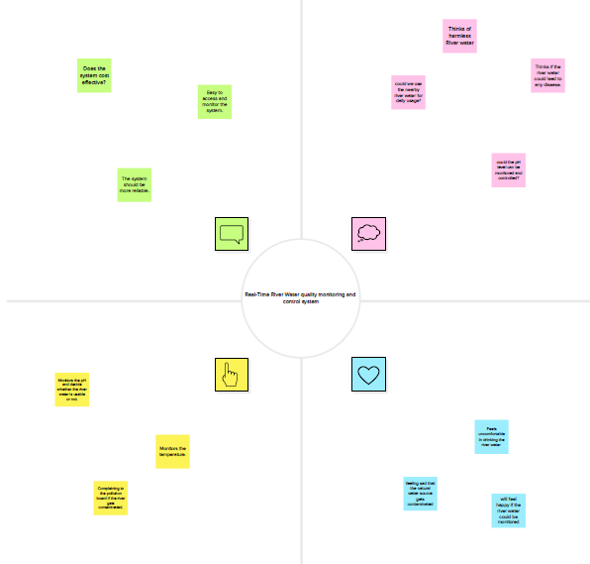

**3.3 Ideation**

**Brainstorm & Idea Prioritization**

Step-1: Team Gathering, Collaboration and Select the Problem Statement

Step-2: Brainstorm, Idea Listing and Grouping

Step-3: Idea Prioritization

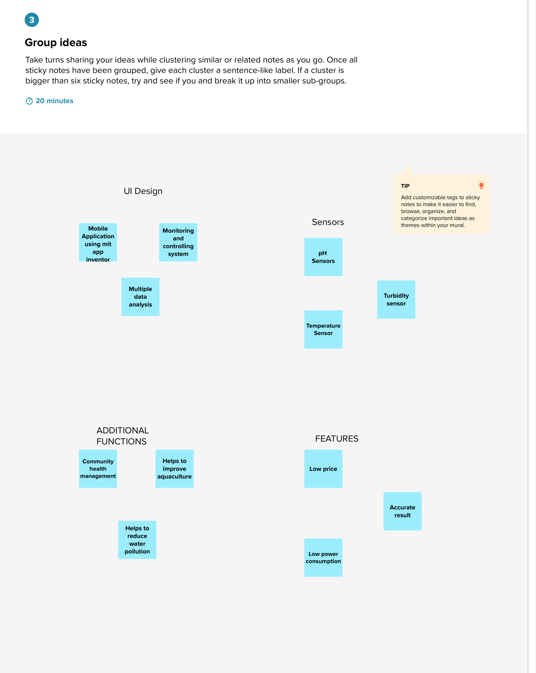

**3.4 Problem Statement**

|  |  |  |
| --- | --- | --- |
| **I am (Customer)** | An authorised person who is supposed to ensure the safety of common people. | Common people living around a river mostly depend on that river for water usage. So it is important to make sure that the river water is safe to use. |
| **I am trying to** | Monitor the River Water quality. | Wants to monitor the river water quality consumed by the people by checking its pH value, Turbidity and dust particles in it. |
| **BUT** | The existing models are not accurate. | Accuracy of the existing model is not enough to monitor efficiently in rainy seasons. |
| **Because** | They are of High cost and consumes high power and doesn’t have automated monitoring systems. | It is difficult to alert about the lack of quality of water at every single time. |
| **Which makes me feel** | Worried about the safety of the people. | So, If the authorised person is not aware whether the water is contaminated or not, he won’t be able to give alerts to residents near the river. Which could lead to disease spread. |

**CHAPTER 4**

**4.1 Proposed Solution**

**Proposed Solution Template:**

Project team shall fill the following information in proposed solution template.

|  |  |  |
| --- | --- | --- |
| **S.No.** | **Parameter** | **Description** |
|  | Problem Statement (Problem to be solved) | Often people and other living organisms are suffered due to unavailability of pure usable water.Due to this health hazards and other infections are spreaded among people. In order to secure them it is necessary to develop a system to handle the quality of water. This can also help the people to have an idea on drinkable water. |
|  | Idea / Solution description | * So, to start this, we just need to know or have an idea on the chemical composition of water or simply the nature of water * Based on timely taken analysis we canfind the nature of water . * Use a random location on taking the amount of chemicals and impuritiespresent in water. |
|  | Novelty / Uniqueness | Low investment and maintainace cost , This system developed is useful and creates an ease of pure water consumption for natives aswellas other beings. |
|  | Social Impact / Customer Satisfaction | * This helps the people to save time and energy as they can get pure river water with ease. * Building an effective system that can be create as a product for best water quality and control system. |
|  | Business Model (Revenue Model) | Many other parts of the world and rural parts of the village are expecting this technology that can greatly facilitate the river water quality management system. |
|  | Scalability of the Solution | The process of operating is easy and it can be designed according to customer needs. |

**4.2 Problem Solution Fit**

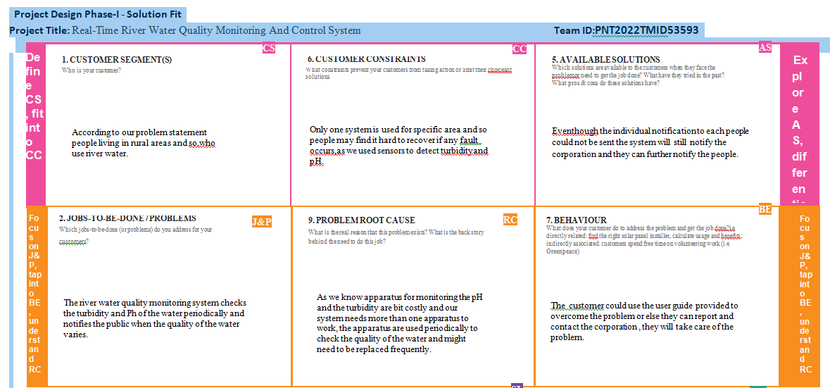

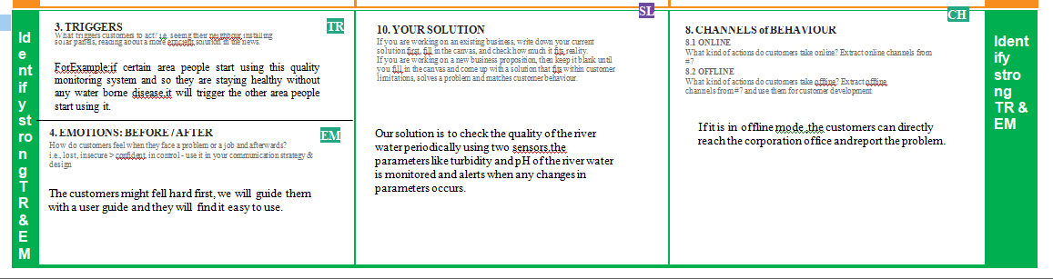

**4.3 Solution Architecture**

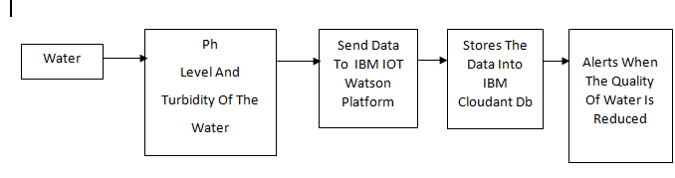

Example- Solution Architecture Diagram:

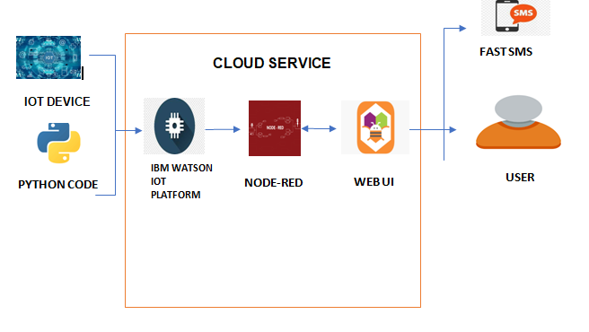

**PROJECT DESCRIPTION:**

* River water quality can be monitored by the web application.
* The web application and the user are interfaced.
* The pH level and the turbidity of the water can be monitored.
* If the water quality is not good then the authorities get alerted by the message.

**CHAPTER 5**

**PROJECT DESIGN PHASE 2**

**5.1 Customer Journey Map**

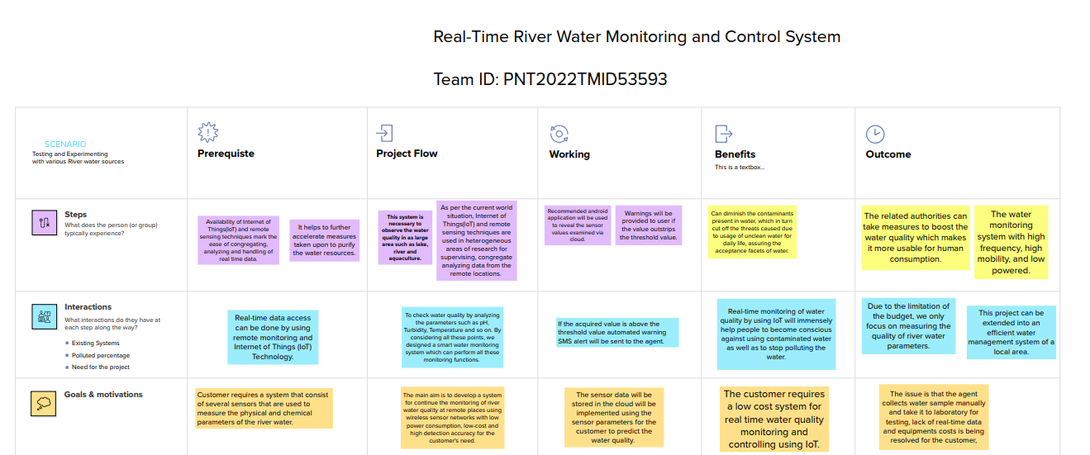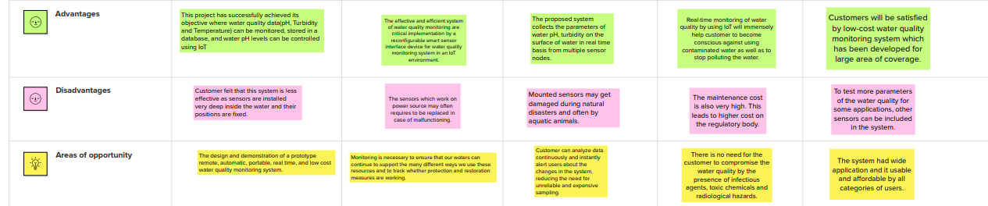

**5.2 Requirement Analysis**

**Functional Requirements:**

Following are the functional requirements of the proposed solution.

|  |  |  |
| --- | --- | --- |
| **FR No.** | **Functional Requirement (Epic)** | **Sub Requirement (Story / Sub-Task)** |
| FR-1 | User Registration | 1. Registration through Form 2. Registration through Gmail |
| FR-2 | User Confirmation | 1. Confirmation via Email 2. Confirmation via OTP |
| FR-3 | User Access | 1. Accepting all the terms and conditions. 2. Confirmation of recaptcha. |
| FR-4 | User Mode | Online. |
| FR-5 | User alert | Alert SMS to the registered mobile number if the  measured value crosses the threshold value. |

**Non-functional Requirements:**

Following are the non-functional requirements of the proposed solution.

|  |  |  |
| --- | --- | --- |
| **FR No.** | **Non-Functional Requirement** | **Description** |
| NFR-1 | **Usability** | 1. Easy to use.  2. Effective, Efficient, Engaging, Error tolerant.  3. Easy to learn. |
| NFR-2 | **Security** | 1. Accepting Terms and Conditions.  2. Confirmation via Email and OTP.  3. Confirmation via recaptcha.  4. Strong cryptography skills.  5. Software security architects also have experience with malware, intrusion detection and prevention and firewalls. |
| NFR-3 | **Reliability** | 1. Great user interface.  2. Software operating without failure while in a specified environment over a set duration of time. |
| NFR-4 | **Performance** | Fast loading of result time and high performance. |
| NFR-5 | **Availability** | Easy installation. |
| NFR-6 | **Scalability** | 1. Optimizing SQL queries and implementing indexing strategies.  2. By building articles and authors into a single query, we can dramatically reduce the volume of queries we're running. |

**5.3 Data Flow Diagrams**

**Data Flow Diagrams:**

A Data Flow Diagram (DFD) is a traditional visual representation of the information flows within a system. A neat and clear DFD can depict the right amount of the system requirement graphically. It shows how data enters and leaves the system, what changes the information, and where data is stored.

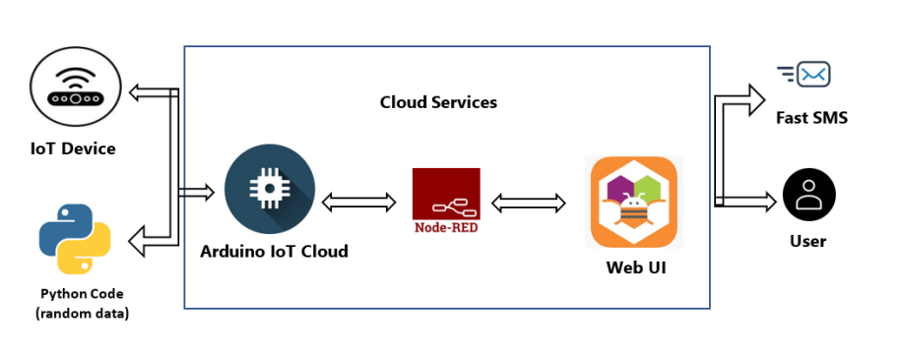

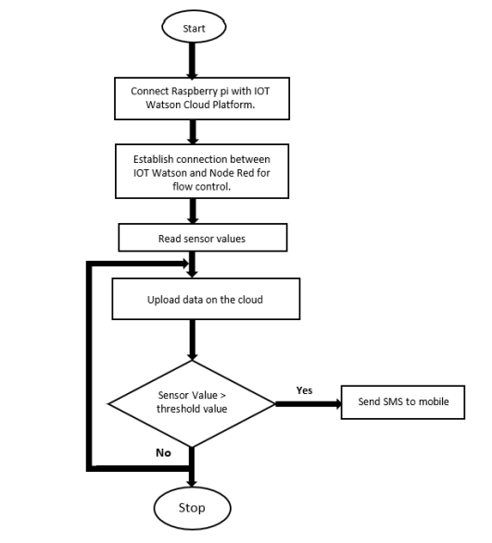

**User Stories**

Use the below template to list all the user stories for the product.

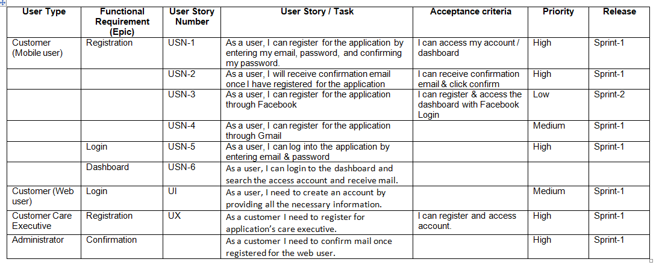

**5.4 Technology Stack**

**Technical Architecture:**

The Deliverable shall include the architectural diagram as below and the information as per the table1 & table 2

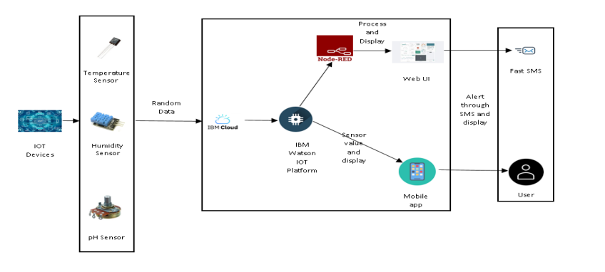

**Table-1 : Components & Technologies:**

|  |  |  |  |
| --- | --- | --- | --- |
| **S.No** | **Component** | **Description** | **Technology** |
|  | User Interface | Web UI, Mobile App | Node – Red, Kubernetes, MIT mobile app inventor. |
|  | Application Logic-1 | Generate Random data | Python |
|  | Application Logic-2 | Generate random sensor data | IBM Watson IoT service |
|  | Cloud Database | Database Service on Cloud | IBM DB2, IBM Cloudant. |
|  | External API-1 | Send SMS to customer | Fast SMS API. |
|  | Infrastructure (Server / Cloud) | Application Deployment on Cloud | Cloud Foundry, Kubernetes. |

**Table-2: Application Characteristics:**

| **S.No** | **Characteristics** | **Description** | **Technology** |
| --- | --- | --- | --- |
|  | Open-Source Frameworks | The open-source tools we utilized to create our project | Node – Red, IBM Cloudant, IBM Watson IOT Platform. |
|  | Security Implementations | Use of a login page with a user's unique username and password on a web interface optimized for mobile devices and computers with adjustable screen sizes | Password protection in MIT App. |
|  | Scalable Architecture | optimized for mobile devices and computers with adjustable screen sizes | Node Red(Web UI) |
|  | Availability | accessible to users through both a web UI and a mobile app | Node Red(Web UI), MIT App(Mobile app). |
|  | Performance | Give precise results and a prompt warning in the event of water contamination | Node Red(Web UI), MIT App(Mobile app). |
|  |  |  |  |

**CHAPTER 6**

**PROJECT PLANNING PHASE**

**6.1 Milestone and Activity list**

|  |  |  |
| --- | --- | --- |
| Title | Description | Date |
| Literature Survey on The Selected Project and Information Gathering | A Literature Survey is a compilation summary of research done previously in the given topic. Literature survey can be taken from books, research paper online or from any source. | 28 September 2022 |
| Prepare empathy map | Empathy Map is a visualization tool which can be used to get a better insight of the customer. | 28 September 2022 |
| Ideation-Brainstorming | Brainstorming is a group problem solving session where ideas are shared, discussed and organized among the team members | 5 November 2022 |
| Define Problem Statement | A Problem Statement is a concise description of the problem or issues a project seeks to address. The problem statement identifies the current state, the desired future state and any gaps between the two | 5 November 2022 |
| Problem Solution Fit | This helps us to understand the thoughts of the customer their likes, behaviour, emotions etc. | 5 November 2022 |
| Proposed Solution | Proposed solution shows the current solution and it helps is going towards the desired result until it is achieved. | 5 November 2022 |
| Solution Architecture | Proposed solution shows the current solution and it helps is going towards the desired result until it is achieved. | 5 November 2022 |
| Customer Journey | It helps us to analyse from the perspective of a customer, who uses our project. | 10 November 2022 |
| Functional Requirements | Here functional and nonfunctional requirements are briefed. It has specific features like usability, security, reliability, performance, availability and scalability. | 10 November 2022 |
| Data Flow Diagram | Data Flow Diagram is a graphical or visual representation using a standardised set of symbols and notations to describe business operations through data movement. | 10 November 2022 |
| Technology Architecture | Technology Architecture is a better defined version of solution architecture. It helps us analyze and understand various technologies that need to be implemented in the project. | 10 November 2022 |
| Milestones and Activity list | It helps us to understand and evaluate our own progress and accuracy so far. | 12 November 2022 |
| Sprint Delivery Plan | Sprint planning is an event in scrum that kicks off the sprint. The purpose of sprint planning is to define what can be delivered in the sprint and how that work will be achieved. | In Progress |

**6.2 Sprint Delivery Plan**

**Product Backlog, Sprint Schedule, and Estimation (4 Marks)**

Use the below template to create product backlog and sprint schedule

| **Sprint** | **Functional Requirement (Epic)** | **User Story Number** | **User Story / Task** | **Story Points** | **Priority** | **Team Members** |
| --- | --- | --- | --- | --- | --- | --- |
| Sprint-1 |  | USN-1 | Creating IBM Cloud and using its services. | 6 | High | M. Kalaivanan  S. Jayalakshman  K. Jeeva  S. Kabileshwar |
| Sprint-1 |  | USN-2 | Configure the IBM cloud service and creating IoT platform. | 4 | High | M. Kalaivanan  S. Jayalakshman  K. Jeeva  S. Kabileshwar |
| Sprint-1 |  | USN-3 | IBM Watson IoT platform acts as the mediator to connect the web application to IoT devices, hence Launching IBM Watson IoT platform. | 5 | Low | M. Kalaivanan  S. Jayalakshman  K. Jeeva  S. Kabileshwar |
| Sprint-1 |  | USN-4 | In order to connect the IoT device to the IBM Cloud, create a device in the IBM Watson IoT Platform and get the device credentials | 5 | Medium | M. Kalaivanan  S. Jayalakshman  K. Jeeva  S. Kabileshwar |
| Sprint-2 |  | USN-1 | Configure the connection security and create API keys that are used in the NODE-RED service for accessing the IBM IoT Platform. | 10 | High | M. Kalaivanan  S. Jayalakshman  K. Jeeva  S. Kabileshwar |
| Sprint-2 |  | US-2 | Create a Node -RED service. | 10 | High | M. Kalaivanan  S. Jayalakshman  K. Jeeva  S. Kabileshwar |
| Sprint-3 |  | US-1 | Develop a python script to publish random sensor data such as temperature, turbidity and pH to the IBM IoT Platform. | 7 | High | M. Kalaivanan  S. Jayalakshman  K. Jeeva  S. Kabileshwar |
| Sprint-3 |  | US-2 | After developing python code, commands are received just print the statements which represent the control of the devices. | 5 | Medium | M. Kalaivanan  S. Jayalakshman  K. Jeeva  S. Kabileshwar |
| Sprint-3 |  | US-3 | Publish data to the IBM Cloud. | 8 | High | M. Kalaivanan  S. Jayalakshman  K. Jeeva  S. Kabileshwar |
| Sprint-4 |  | US-1 | Create Web UI in Node -RED. | 10 | High | M. Kalaivanan  S. Jayalakshman  K. Jeeva  S. Kabileshwar |
| Sprint-4 |  | US-2 | Configure the Node -RED flow to receive data from the IBM IoT Platform and also use Cloudant DB nodes to store the received sensor data in Cloudant DB. | 10 | High | M. Kalaivanan  S. Jayalakshman  K. Jeeva  S. Kabileshwar |

**Project Tracker, Velocity & Burndown Chart: (4 Marks)**

| **Sprint** | **Total Story Points** | **Duration** | **Sprint Start Date** | **Sprint End Date (Planned)** | **Story Points Completed (as on Planned End Date)** | **Sprint Release Date (Actual)** |
| --- | --- | --- | --- | --- | --- | --- |
| Sprint-1 | 20 | 6 Days | 24 Oct 2022 | 29 Oct 2022 | 20 | 29 Oct 2022 |
| Sprint-2 | 20 | 6 Days | 31 Oct 2022 | 05 Nov 2022 | 20 | 05 Nov 2022 |
| Sprint-3 | 20 | 6 Days | 07 Nov 2022 | 12 Nov 2022 | 20 | 12 Nov 2022 |
| Sprint-4 | 20 | 6 Days | 14 Nov 2022 | 19 Nov 2022 | 20 | 19 Nov 2022 |

**Velocity:**

Imagine we have a 10-day sprint duration, and the velocity of the team is 20 (points per sprint). Let’s calculate the team’s average velocity (AV) per iteration unit (story points per day)



**Burndown Chart:**

A burn down chart is a graphical representation of work left to do versus time. It is often used in agile software development methodologies suchas Scrum. However, burn down charts can be applied to any project containing measurable progress over time.

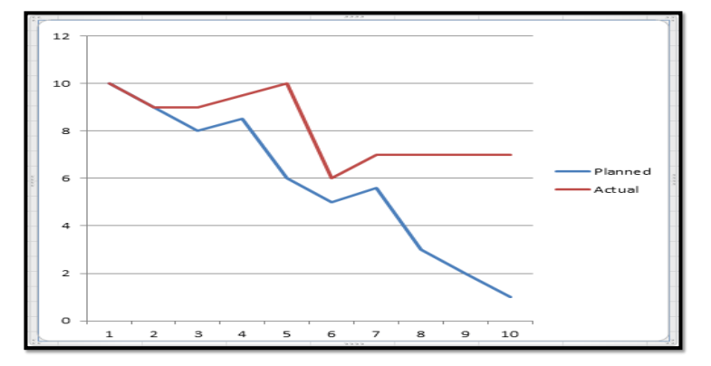

**CHAPTER 7**

**PROJECT DEVELOPMENT PHASE**

**7.1 Project Development – Delivery of Sprint-1**

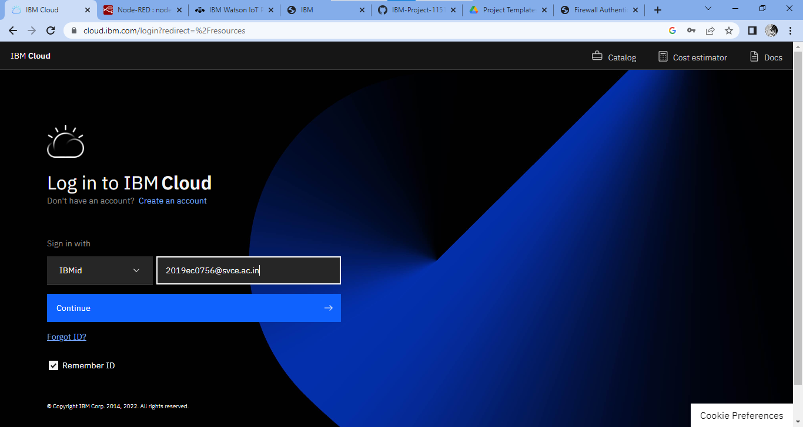

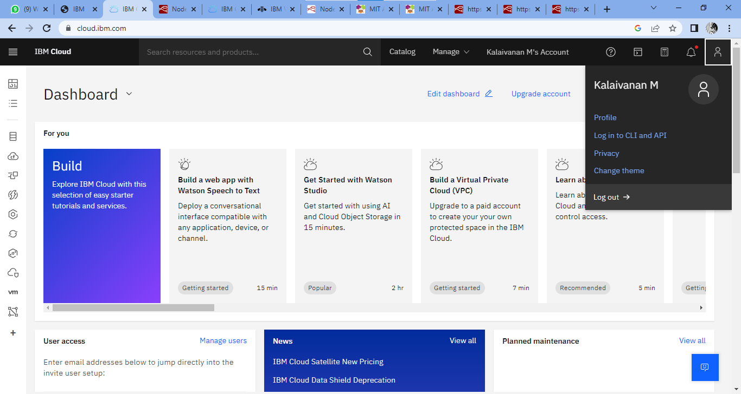

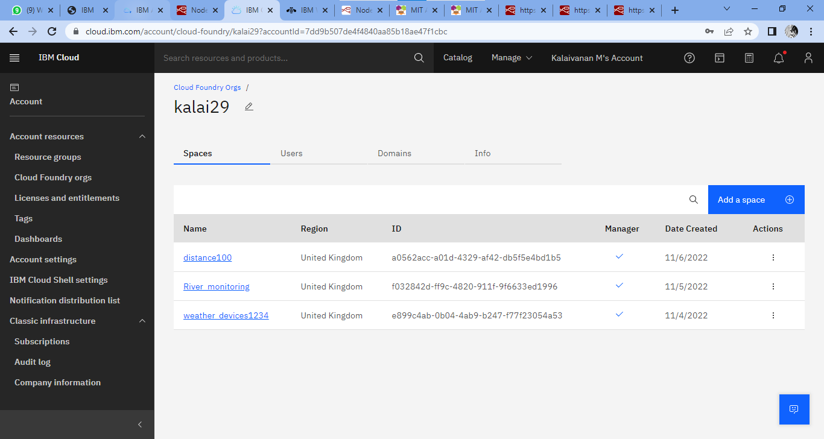

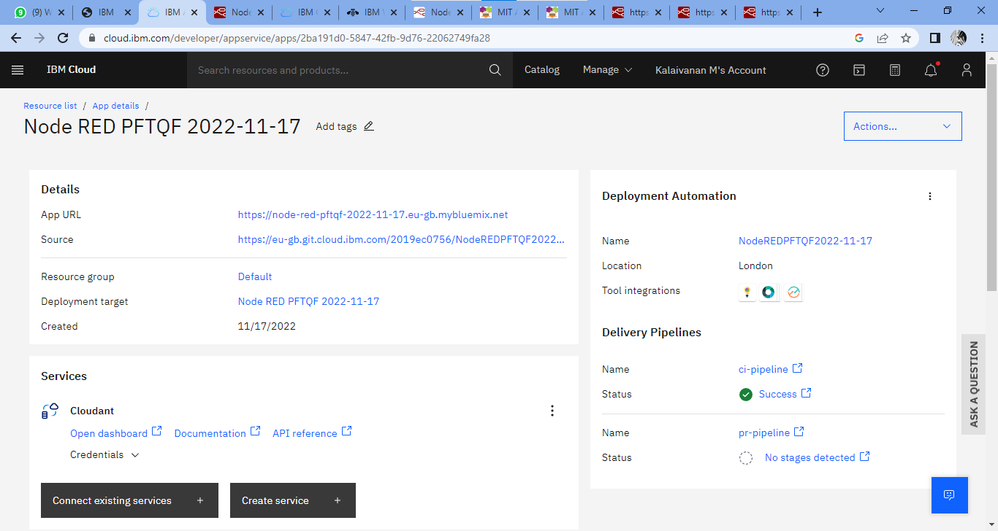

**7.2 Project Development – Delivery of Sprint – 2**

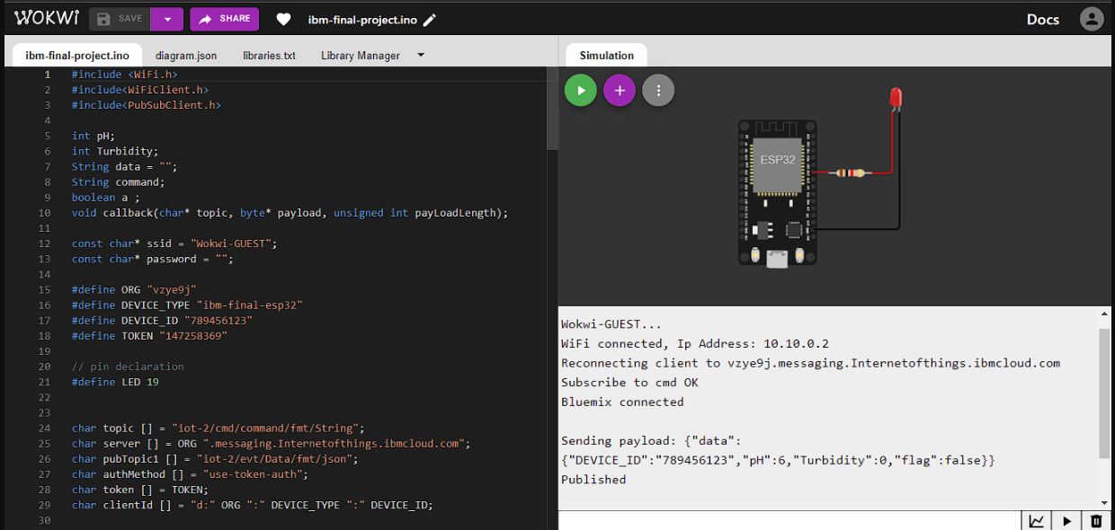

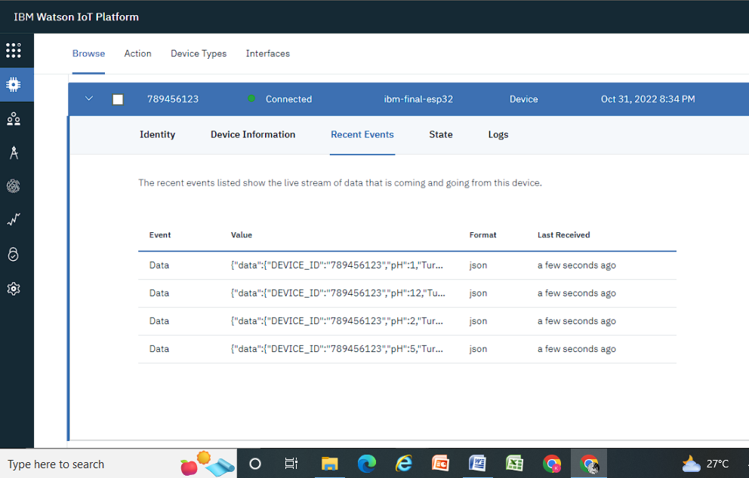

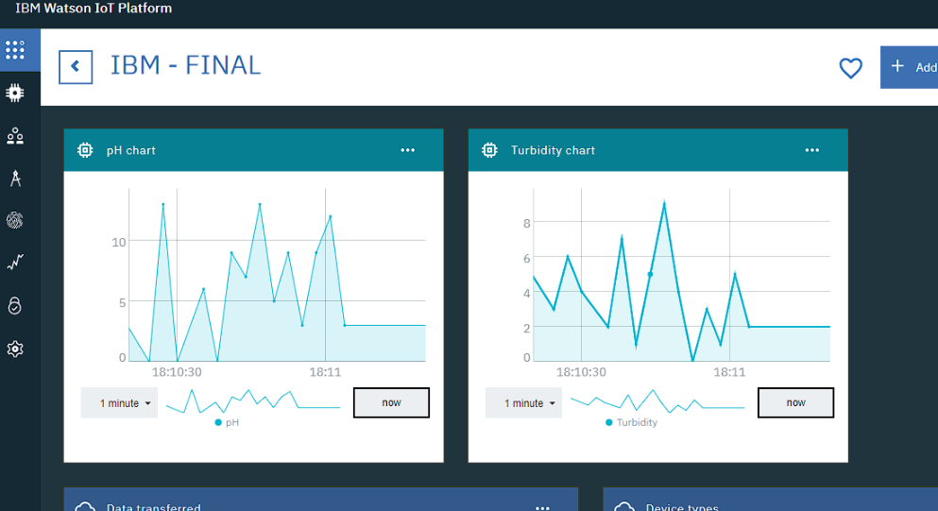

**7.3 Project Development – Delivery of Sprint – 3**

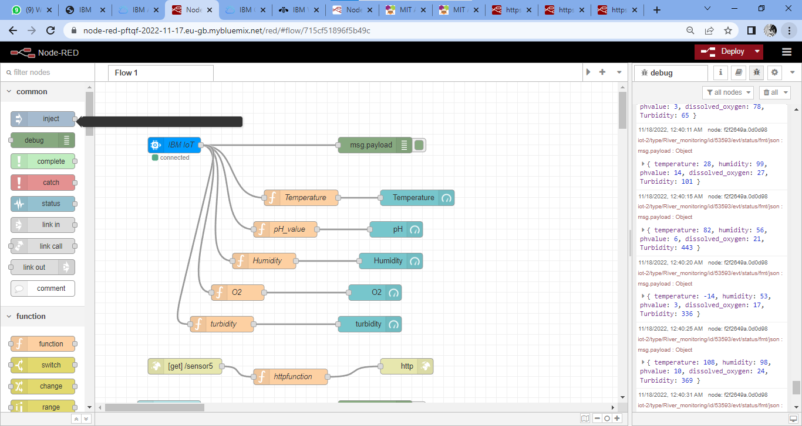

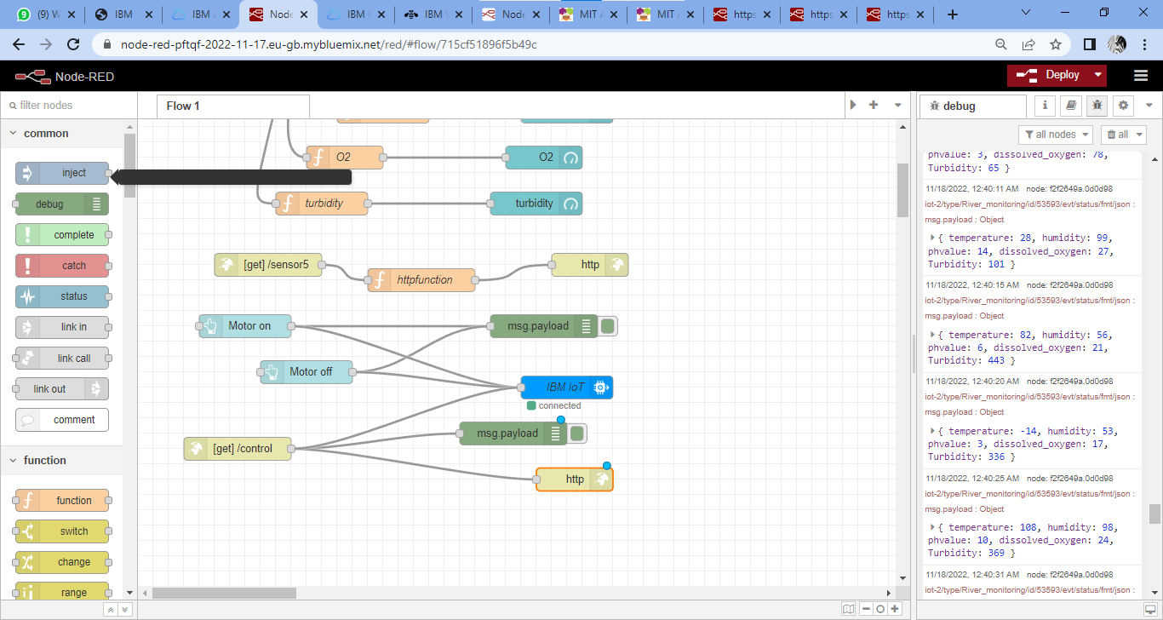

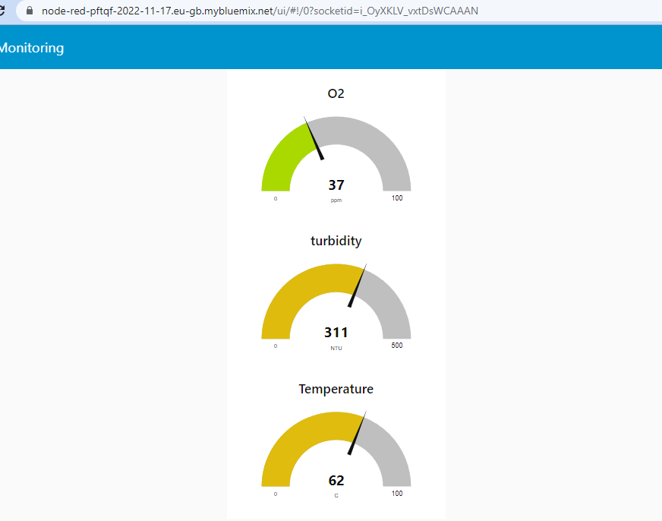

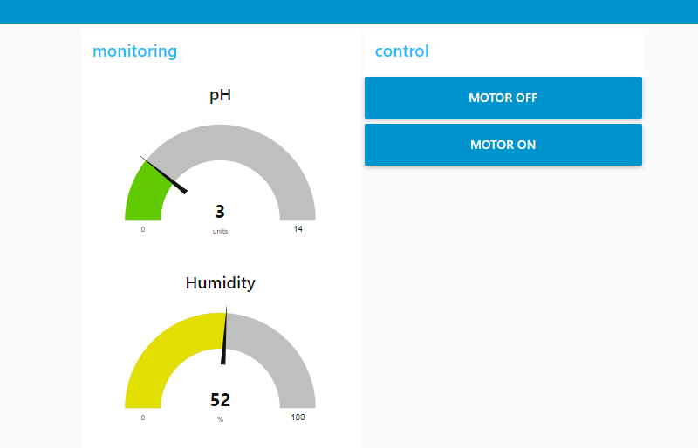

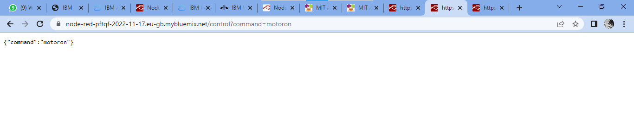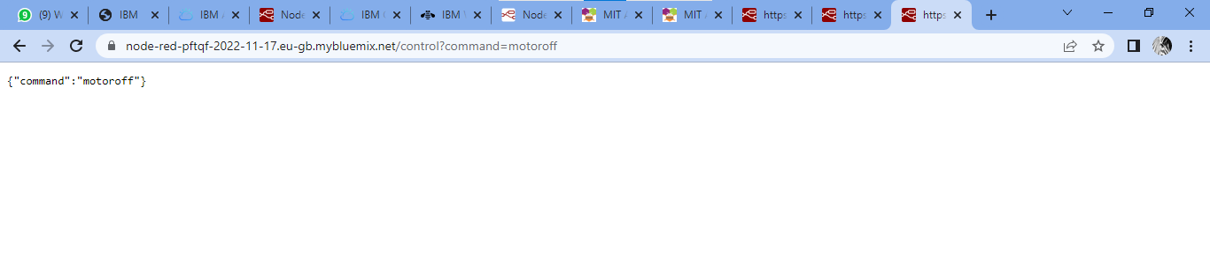

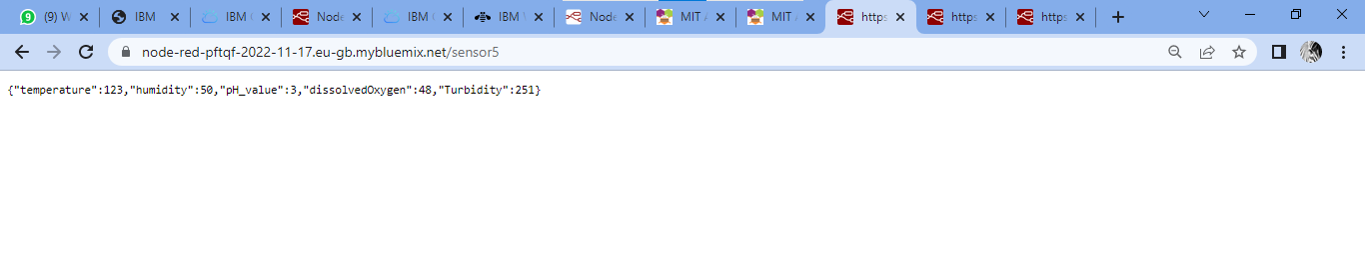

**7.4 Project Development – Delivery of Sprint – 4**

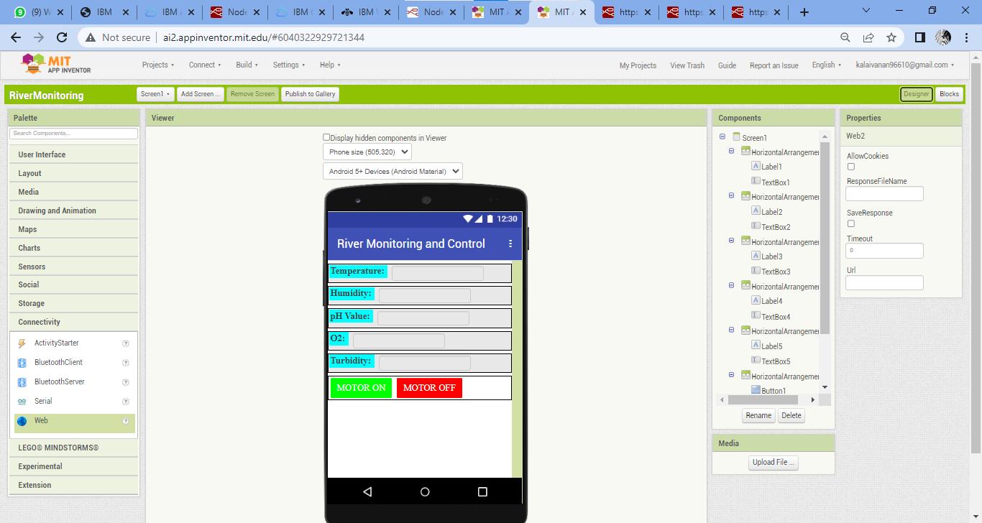

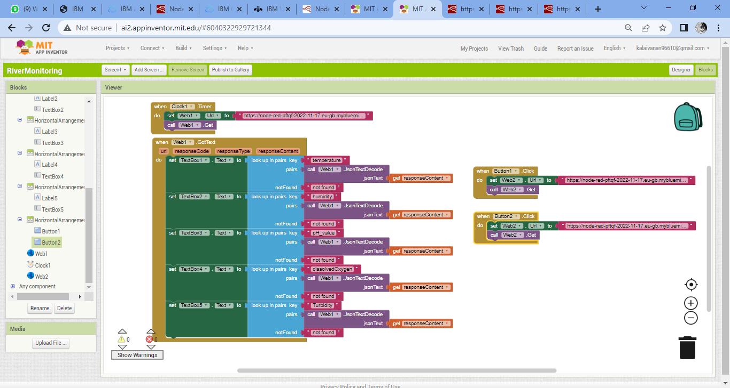

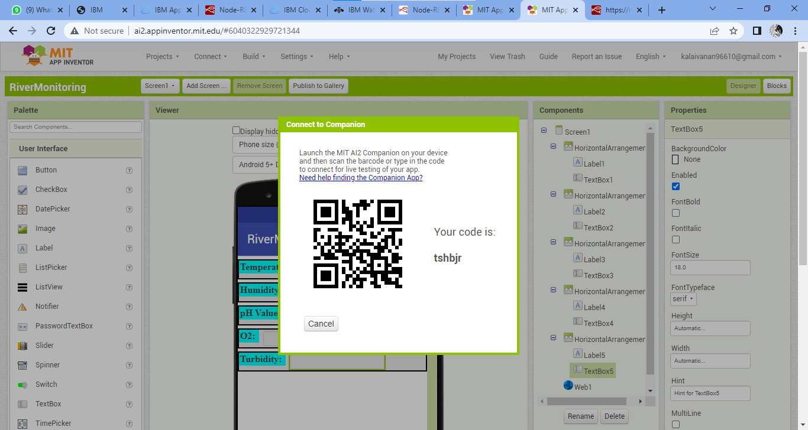

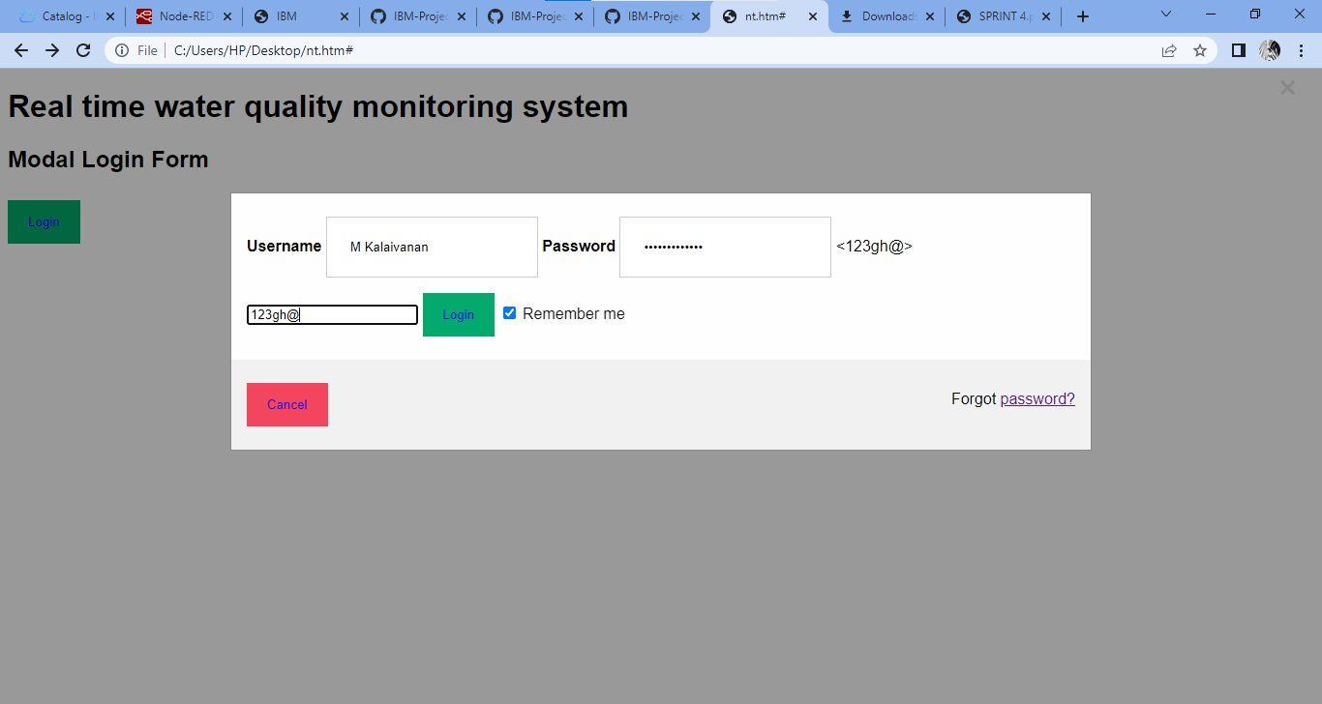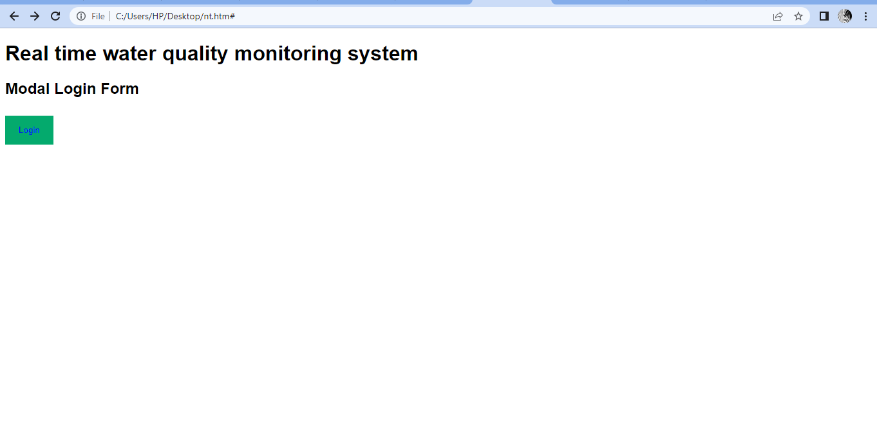

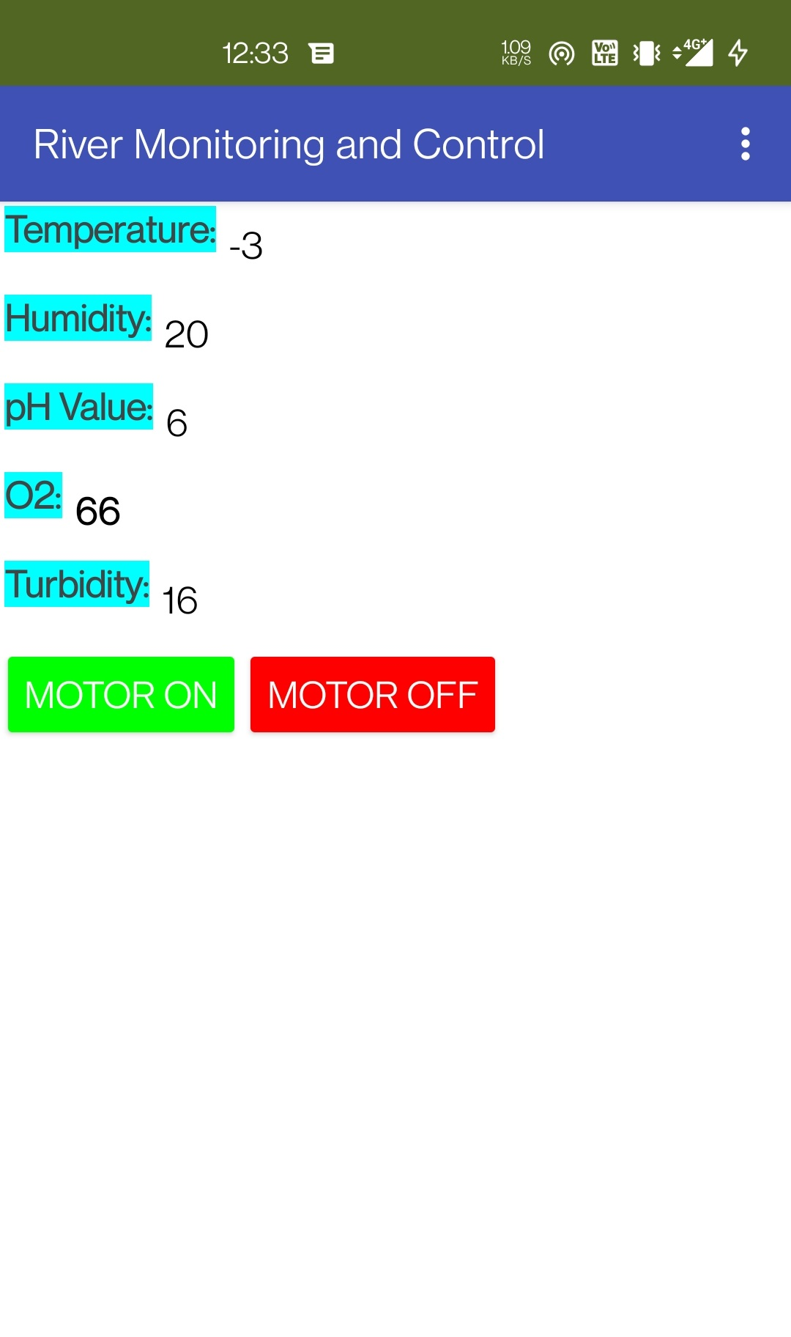

**CONCLUSION**

Real-time monitoring of water quality by using IoT will immensely help people to become conscious against using contaminated water as well as to stop polluting the water. The research is conducted focusing on monitoring river water quality in real-time. Therefore, IoT is appeared to be a better solution as reliability, scalability, speed, and persistence can be provided.

IoT devices use various types of sensors to collect data about turbidity, ORP, temperature, pH, conductivity, etc. Of river water continuously. Also, IoT devices have capability to stream the array of collected data wirelessly to the remote Data Aggregator Server in the cloud. Moreover, the volume of semi structured data increases with time in such a velocity that only the Big Data Analytics applications can efficiently store and analyze the data constantly. Due to the limitation of the budget, we only focus on measuring the quality of river water parameters. This project can be extended into an efficient water management system of a local area. Moreover, other parameters which wasn’t the scope of this project such as total dissolved solid, chemical oxygen demand and dissolved oxygen can also be quantified. So the additional budget is required for further improvement of the overall system.

**REFERENCES**

1. K. S. Adu-Manu, C. Tapparello, W. Heinzelman, F. A. Katsriku, and J.-D. Abdulai, "Water quality monitoring using wireless sensor networks: Current trends and future research directions," ACM Transactions on Sensor Networks (TOSN), vol. 13, p. 4, 2017.
2. B. Chen, Y. Song, T. Jiang, Z. Chen, B. Huang, and B. Xu, "Real-time estimation of population exposure to PM2.5 using mobile- and station-based big data," Int J Environ Res Public Health, vol. 15, Mar 23 2018
3. B. Paul, "Sensor based water quality monitoring system," BRAC University, 2018.
4. K. Andersson and M. S. Hossain, "Smart Risk Assessment Systems using Belief-rule-based DSS and WSN Technologies", in 2014 4th International Conference on Wireless Communications, Vehicular Technology, Information Theory and Aerospace and Electronic Systems, VITAE 2014 : Co-located with Global Wireless Summit, Aalborg, Denmark 11-14 May 2014, 2014.
5. S. Thombre, R. U. Islam, K. Andersson, and M. S. Hossain, "IP based Wireless Sensor Networks : performance Analysis using Simulations and Experiments", Journal of Wireless Mobile Networks, Ubiquitous Computing, and Dependable Applications, vol. 7, no. 3, pp. 53–76, 2016
6. K. Andersson and M. S. Hossain, "Heterogeneous Wireless Sensor Networks for Flood Prediction Decision Support Systems", in 2015 IEEE Conference on Computer Communications Workshops (INFOCOM WKSHPS) : 6th IEEE INFOCOM International Workshop on Mobility Management in the Networks of the Future World, 2015, pp. 133–137.
7. S. Thombre, R. U. Islam, K. Andersson, and M. S. Hossain, "Performance Analysis of an IP based Protocol Stack for WSNs", in Proceedings of the 2016 IEEE Conference on Computer Communications Workshops (INFOCOM WKSHPS), 2016, pp. 691–696
8. M. Z. Abedin, A. S. Chowdhury, M. S. Hossain, K. Andersson, and R. Karim, "An Interoperable IP based WSN for Smart Irrigation Systems", presented at the 14th Annual IEEE Consumer Communications & Networking Conference, Las Vegas, 8-11 January 2017, 2017.
9. M. Z. Abedin, S. Paul, S. Akhter, K. N. E. A. Siddiquee, M. S. Hossain, and K. Andersson, "Selection of Energy Efficient Routing Protocol for Irrigation Enabled by Wireless Sensor Networks", in Proceedings of 2017 IEEE 42nd Conference on Local Computer Networks Workshops, 2017, pp. 75–81.
10. N. Chilamkurti, S. Zeadally, A. Vasilakos, and V. Sharma, "Cross-layer support for energy efficient routing in wireless sensor networks," Journal of Sensors, vol. 2009, 2009.
11. H. R. Maier and G. C. Dandy, "The use of artificial neural networks for the prediction of water quality parameters," Water resources Research, vol. 32, pp. 1013-1022, 1996
12. T. Mahmud, K. N. Rahman, and M. S. Hossain, "Evaluation of Job Offers Using Evidential Reasoning", Global Journal of Computer Science and Technology, Vol. 13, No. 6, 2013, pp. 41-50.
13. M. S. Hossain, K. Andersson, and S. Naznin, "A Belief Rule Based Expert System to Diagnose Measles under Uncertainty", in Proceedings of the 2015 International Conference on Health Informatics and Medical Systems (HIMS’15), 2015, pp. 17–23.
14. M. S. Hossain, S. Rahaman, A.-L. Kor, K. Andersson, and C. Pattison, "A Belief Rule Based Expert System for Datacenter PUE Prediction under Uncertainty", IEEE Transactions on Sustainable Computing, vol. 2, no. 2, pp. 140–153, 2017.
15. M. Z. Abedin, N. A. Chandra, D. Prashengit, D. Kaushik, and M. S. Hossain, “License Plate Recognition System Based On Contour Properties and Deep Learning Model” in Proceedings of the IEEE Region 10 Humanitarian Technology Conference, 2017, pp. 590-593.